KINGSTONE & THRUXTON GROUP PARISH COUNCIL
Minutes of the Ordinary Meeting of the Parish Council held on 3rd September 2025
At 19.00 in Kingstone Village Hall, Green Lane, Kingstone, Hereford
Present:
Cllr Colin Pugh (Chairman), Cllr Colin Warrillow (Vice Chairman), Cllr David Bailey, Cllr Leah Dunsmuir, Cllr Neil Howard, Cllr Colin Knight, Cllr Denise Lloyd, Cllr Paula Rawbone, Cllr David Rea and Cllr Christina Richards.
In attendance: Lisa Lewis (Parish Clerk), Ward Cllr Richard Thomas, Matt Heeley (Lengthsman), Aiden Baldwin (Sports Association), Paul Neate (Footpaths Officer), and three members of the public were present.
The meeting was opened at 7.00pm.

1. Apologies for Absence
Apologies were received and accepted from Cllr Alexis Richards-Powell.

2. Declarations of Interest
Cllr P. Rawbone declared an interest in item 7.1 of the agenda. The declaration of interest book was signed by Cllr Rawbone.

3. Minutes
It was RESOLVED to adopt the minutes of the ordinary meeting held on Wednesday 2nd Juy 2025 as a true record and they were signed by the chairman.

4. Public Participation
Open session – The following matters were raised:-
- Flooding and discharge of water affecting Barrow Common. The chairman advised that a meeting with Flood Consultants WSP had taken place today and work to address problems will continue. All problem areas had been noted by WSP and we will await the report. He confirmed that the parish council are actively engaging with the relevant bodies to try and reduce the impact of flooding. The resident also advised that water needs to get away and ditches need to be cleared – can the parish council liaise with the farmer. The chairman confirmed that a meeting had already been held with the land agent.
- Cllr Dunsmuir confirmed that as part of the flood response plan from Herefordshire Council, equipment including aqua sacks are to be provided to the parish. It was RESOLVED to add an item for Sandbags to the next agenda.

5.1 Clerk’s Report & Correspondence
Correspondence:-

The clerk had been notified that a drain on dews corner had been filled with debris from recent drainage/resurfacing works. The clerk contacted Andy Byng at Highways who was out of the office, therefore reported to BBLP for investigation. BBLP Ref:- 11190103. Andy has since confirmed that Tarmac will jet the drain.

WSP Flood Investigation email was received and a meeting arranged for 03.09.25. The meeting had taken place today and was attended by the chairman, clerk, Cllr Dunsmuir and the lengthsman.

Email received from a resident in Thruxton regarding the ditch outside Pool House – the message was passed to the lengthsman for inspection on next visit. The Lengthsman has investigated, and the parish council have included this location in the drainage grant application.

Email from a resident in Kingstone to advise that the corners of the grass triangle outside the Church had been damaged by vehicles carrying out renovation work on the adjacent property. Photos were provided. It was RESOLVED for the clerk to write to the residents of the property and request that the corners are re-installed on completion of works.

HALC – Information Corner, pay agreement and other documents circulated. (14.08.25)

Email received from Open Spaces Society with regard to footpath KS32. Email circulated to include PFO. It was RESOLVED for the clerk to forward the issue to Herefordshire Council.

Quarterly Stakeholder Meeting with BBLP to take place via Zoom 26/09/2025 at 11am. Councillors to confirm attendance with the clerk.

HALC Training Schedule circulated. Noted by the council, councillors to contact the clerk to book any sessions.
Call For Land support available email received and circulated. Noted by the council.

Community Flood Equipment Pilot Scheme – email received and circulated stating that equipment will be provided to the parish. A Flood Plan Template was provided for Parishes to adopt as their own and a meeting will take place at the Town Hall in Hereford on 24th September. It was RESOLVED that a working group be formed consisting of the Clerk, Cllrs Pugh and Dunsmuir and they will draft a Parish Flood Plan in liaison with members of the public and attend the meeting held by Herefordshire Council.

Planning Decisions – FOR INFORMATION ONLY
P251983 - 15 Whitehouse Drive Kingstone Hereford Herefordshire HR2 9ER - Proposed two-storey extension to side elevation. Determination Made (Approved with Conditions).

Brief Reports (as available)
5.1 Police – not present
5.2 Ward Cllr Richard Thomas – reported on the following:-
- He had attended the first meeting back after summer being the Planning Committee meeting. The chairman raised several issues concerning Coldstone Common, hedges at Kingstone Grange Development on the roadside and BT Path – the Ward Cllr will address these issues. It was noted that the sewerage works outside development have been completed.

5.3 Lengthsman – Reported on the following:-
- A road sweep had been carried out from Church View to and including Whitehouse Drive.
- Looking to carry out another sweep before the end of the year but need assistance from parish council to ensure vehicles are removed for the sweep – this includes the areas of Coldstone Cross and Green Lane.
- Drainage Grant Application for 2025/26 is now complete for submission.
- He had attended the flood investigation meeting with WSP.
- Looked at public rights of way grant work. Met with Whitfield Estate Owners and Managers to look at drainage.
- Railings and headwall on the B4348 had been cleared of vegetation and will be added to the maintenance plan going forward.
It was noted that Cooks Lane hedge is overgrown and RESOLVED for the clerk to contact the Estate Manager and request the hedge be cut.
5.4 Village Hall – Cllr Rawbone reported:-
- Unfortunately, the hall had been subject to a burst pipe in the roof which had caused a flood and water damage to the ceiling in the ladies’ toilets. The pipe had been repaired but the area now needs to dry out before redecoration.
- Grants have been applied for.
- The chairman requested a copy of the charity’s constitution to better understand the parish councils position on the hall, this was in regard to the councils asset register. Cllr Rawbone will obtain.
5.5 Sports Association – Mr Aiden Baldwin introduced himself as the new chairman for the Sports Association, alongside Mr Dan Hughes (not present) as vice-chairman. He confirmed that the next maintenance days will take place on 7th and 14th September. The old football goals are being removed as they don’t meet regulations and new mobile ones are being installed. The manager of one of the football teams is now on the committee and they have set up a social media page on Facebook named ‘Seven Site’. Fundraising has been discussed by committee members and updates will follow. They are looking forward to working collaboratively with the parish council. The chairman requested a copy of the charity’s constitution, again to better understand any commitments that the parish council hold. There was a request for the nettles under benches and equipment to be cleared and it was confirmed this will be carried out at a maintenance day.

5.6 Footpaths – Paul Neate (PFO) handed around an updated map of paths walked and cleared. Throughout July and August he has maintained the BT Path (KS26), KS5, Barrow Common Bridge. KS3 at Thruxton, gateway cleared and a resident cleared trees from the KS1. Dog fouling signs have been displayed at either end of the new path across the orchard behind Whitehouse Drive. He reported a fallen tree branch to the Estate and this was cleared promptly. KS7 gate has been damaged, the bolt had been bent and he couldn’t find a replacement, but he has secured to the fence so that the gate doesn’t disappear. Clerk to report to Landowner. Footpath sign down on the KS16. Strimmer has gone in to Ron Smiths under warranty for the second time and is awaiting a replacement part, which will be repaired under warranty but approximately £70-00 invoice to pay for other maintenance. This was approved by council. Paul asked the council to consider purchase of a self-propelled trimmer – Paul will find prices, clerk to add to the next agenda.
5.7 Bike Track – Cllr Warrillow had spoken with children using the track to gather feedback. They would like to see the jumps improved. It was agreed for Cllr Warrillow to obtain quotes to review and upgrade the track and surface without a permanent option such as tarmac and will report back. It was noted that the track looks tidy and litter picks are carried out regularly.
5.8 Allotments – no updates to report. The next Committee meeting will take place in October.
5.9 Food Share – The foodshare continues successfully with more regulars attending. Cash donations had been received and passed to the clerk for banking.
5.10 Litter Picking – Five volunteers and a baby attended the last litter pick and five bags of rubbish were collected. The next litter pick takes place on Sunday 7th September with coffee and cake after in the pub.

6. Finance & Policy
6.1 The payments list for September was approved along with the payments list for August which had already been paid under delegated authority. All invoices were duly signed by the authorised signatories. See Appendix 1.
6.2 The Bank balances (see appendix 2) for the end of July 2025 were noted and Bank statements were signed by authorised signatories. Receipts were noted. Approximate reserves were noted. .
6.3 The external audit report was noted and it was the clerk confirmed that no matters had been raised. The conclusion notice will be displayed on noticeboards and on the website. The council considered that 4 weeks for the display in noticeboards would be adequate.
6.4 Current spend against budget – item deferred until the next meeting.
6.5 Parish Charter – it was noted that a working group meeting is taking place at the Town Hall and Cllrs Howard and Richards will attend. The charter will also be discussed further at the Parish Summit on the 08/10/2025, councillors were encouraged to attend.
6.6 It was noted that the .gov email address for the council needs to be used rather than the old Hotmail account. The clerk will only be using the .gov email going forward to comply with the audit requirements. The clerk will email all councillors to check who is currently using their .gov addresses and help where necessary.
6.7 All councillors present agreed to accept the summons by email for the remainder of their term of office.
6.8 The chairman reminded councillors that pre-budget planning will commence shortly and if any councillors have projects they would like to undertake please let the clerk know in order to

accommodate this into the budget plan. It was agreed that the chairman, vice-chairman and Cllrs Rawbone and Richards will attend a finance working group meeting to consider the draft budget.

7. Planning and NDP
251957 - 3 Mill Common Cottages, Cottons Meadow, Kingstone, Hereford, Herefordshire HR2 9HU - Proposed change of use to provide ancillary accommodation to 3 Mill Common Cottage and a new access gate to an existing storage area for residential use (part retrospective). The planning application was considered and there was a unanimous vote to support the application with no comments to make.
252375 - Belle Vue, Kingstone, Hereford, Herefordshire HR2 9HF - Proposed alterations and conversion of garage to residential living area. The planning application was considered and there was a unanimous vote to support the application with no comments to make.
7.2 NDP – No updates. It was noted that council priorities at this time are to ensure a flood plan is in place.

8. Highways and Environment
8.1 Highways and Public Rights of Way – None noted.
8.2 Drainage and Flooding issues at Coldstone Common and Flood Investigation meeting with WSP -the chairman confirmed this item had already been covered under item 4 above. The meeting with WSP was attended by the chairman, clerk, Cllr Dunsmuir and the lengthsman, full details of the flooding issues in the village were passed on to WSPand we await the report.
8.3 s.106 Traffic Calming Plans – the chairman advised the plans are still ongoing, there had been a delay due to staffing at Herefordshire Council, we now have a provisional date of November.
8.4 Equipment for Older Children – item deferred.

9. Training
The new training schedule from HALC had been circulated and councillors are to confirm attendance at any sessions with the clerk.

10. Items for Next Agenda
- Sakura Cherry Tree Project
- Action Plan
- Legal obligations to the Parish Council for the Village Hall and Sports Field
- Police – Cold Caller Stickers for vulnerable residents

11. Date of Next Meeting
Wednesday 1st October 2025.

The meeting closed at 8:23pm.

Signed…………………………………………………………………………………………………….. Date…………………………………..

Appendix 1

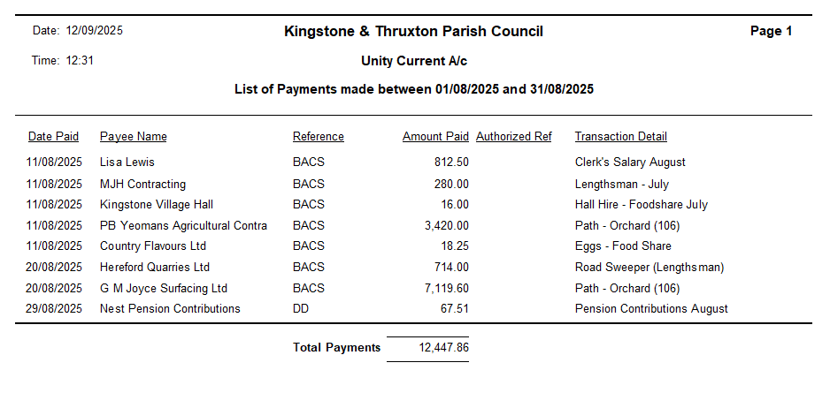

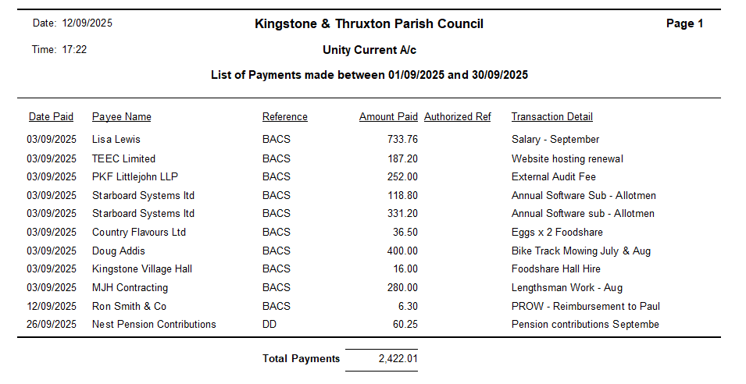

Appendix 2

Bank Statements End of July:-
Current Account – £17,892.96
Savings Account – £33,268.32

